Chapter 1

Background Outline

1. What is recommendation system
2. Why we use recommendation system (please put statistic and graph if needed). A brief example of amazon, lenseview, netflix
3. Recommendation technique CF & CBF a simple explanation and example
4. Content Based explanation (What, why, and how)
5. Why content based will help the current recommendation system

Problem Definition

Scope of Works

Benefits

According to Merriam Webster, recommendation is the act of saying that someone or something is good and deserves to be chosen. We tend to give recommendation in our daily life such as recommending the best coffee in town to our best friends, giving a clue that the last Star Wars movie are worth watching. The essence of recommendation is reliable because we know that the item which is recommended by other people will more likely to satisfy us. As for in our Information Technology society, we define a system that give a recommendation to people is called a Recommender system (RS). This system has become more and more popular in our society and implemented in various application, because it could filter the related data that user interested rather than give all of information to the user. The most popular ones are probably to recommend movies, music, news, books, research articles, search queries, social tags, and products for people. In addition, in October 2006, a big company Netflix open a challenge for public in order to create a recommendation towards their movie recommendations. They offer 1 million US Dollar to improve their recommendation system called *Cinematch* by 10% improvements.

The reason we implement RS in our society are, to create a better content for the user. Firstly, by using RS, be could identify our user behavior. By monitoring their preferences and likes for a certain object the RS will create an output just as like a wizard who know what the customer wants. For example, the Last.fm create a station which contains recommended songs by calculating the user behavior towards the system. The system will also play the song which are not in the user library but played by other people who has similar taste to the music. This behavior also applies to the e-commerce recommendation system such as Amazon. By knowing the user preference, it will create an interactive perspective which give the user a good feeling seeing the item that RS has recommend and persuade them to buy or use the service.

Finally, conversion perspective which helps the company to grow. Such as, increase hit rate, optimize sales and profits margin, and many more. (Jannach, D). Recommendation also helps the company to plan what is the best item or move to be offered to the customer when selling their product or service. As for in IT terms, this tools can be seen in many applications for helping the customer making their next decision. For example, Amazon website, as the user can see several option after they bought or see several items in the website. It said the recommendation tool helps the market gain almost 35% of the profit rates. The other best example taken from “Now Touching The Void and Into Thin Air” example case. In 1988, a British mountain climber name Joe Simpson wrote a book which told his story to be the first to reach the summit of the Siula Grande in the Peruvian Andes with his friend. The book was having a good review which resulting a good success but soon disappearing in years later. Then a decade later, Jon Krakauer wrote a book Into Thin Air which also has the same plot with Joe Simpsons book. Instantly, Joe Simpsons book’s become hits again, the reason behind this is Amazon.com recommendation acknowledge the pattern of their customer buying behavior and told their user that if they liked Now Touching the Void then they will likely to like Into The Thin Air. Their user took the suggestion then it create an impact of a rising demand for unpopular book to become popular.

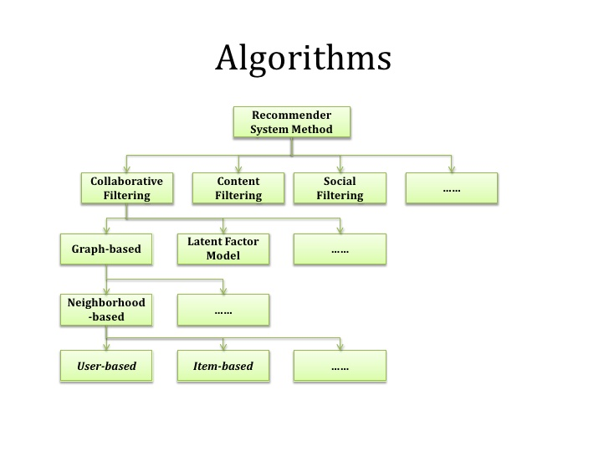

There are several other methodology regarding RS, but the most common algorithm was CBF. According to research conducted by Joeran Beel (2015), from 62 reviewed approaches, 34 used CBF (55%). From these CBF approaches, the majority utilized plain terms contained in the documents. However, there are some fascinating algorithm which can be used to the RS. The Natural Algorithm is an algorithm that mimic an animal or plant behavior to the system. Janusz Sobecki (2014) found that there are several natural algorithms that can be applied towards the RS. One of them is PSO (Particle Swarm Organization), this algorithm was invented in 1995 by Eberhart and Kennedy. This algorithm was based on several things which are, position, velocity and acceleration, and the movement of the particle around space. PSO can be referred as the school of fish, which each fish has their acceleration, coordinate, speed.

**Problem Definition**

Recommendation System has proven to bring great benefits towards human society. For example, it has become the tool for a company to attract more customer by giving them list of item that might interested. Not only it benefits the customer by giving them a less price or targeted item, but also benefits the company by giving them a loyal customer and profits. In these recent day, we can see many variables which can be put to the recommendation system which can be related to the RS. A context, which defined by Merriam Webster as the interrelated conditions in which something exists or occurs. A use of mobile device has a capability for monitoring user location and other service related that can play a part as the context for the RS. For instance, a location is a context which can be putted to a RS to create a recommendation to people near that location. In addition, time is another context that can be assign to give a specific time related recommendation to the user. The author believes, that by implementing the context to the RS will bring a great impact or improvement towards the accuracy to the RS.

**Aims and Benefits**

The Goal of this project can be defined in below

1. To implement context based for CF and CBF Algorithm
2. Creating an automation system or platform
3. Produce a recommendation dataset for PT. XYZ with the platform

The benefits of this thesis are

1. Help the current company to gain more customer and profits
2. The result of this thesis can become the foundation for other people when developing the next recommendation system
3. As the base foundation for the author to create a recommendation platform with the same or similar data in the future

**Scope**

The scope of this thesis are:

1. To identify which algorithm that produce the best result for the PT XYZ. The author will use Content Based Filtering and Collaborative Filtering as the basic recommendation algorithm to use in this thesis
2. The data sample will be collected from the PT XYZ and other source
3. Creating a platform of machine learning in order to process the data
4. The recommendation data will be shown in the company application which is in IOS Applications

**Chapter 2**

**Landasan Theory**

In this chapter, the author will describe and explain regarding the theory that’ve been used for creating this thesis.

**Literature Review**

**----**

**Recommendation System**

Now days, we can see a lot of recommender system (RS) in our modern society. Mostly, the system can be found in the application which has a huge amount of data collections. The reason behind the use of the RS is the system need to provide the user with a list of items that they might buy or interested. In addition, not only providing user with the list of items but also create a personalized RS for each different user.

The basic reason behind the implementation for recommendation system is revenue. Amazon, Netflix, Spotify, and Apple Music are some example of big company who implements RS on their business model. Which proven to increase user engagement towards their application. The company revenue will increase significantly with more user engagement to the application. One of the example for this statement is Netflix. We know that Netflix provide their user with a list amounts of films and the user need to pay a subscription monthly fee in order to get the services. As the user start to select, watch, and rate each of the movie, the RS create a unique list of movie for every user, which make the user want to try to see the recommended movie.

The other simple example is “Now Touching The Void and Into Thin Air” example case. As the author already mentions it in the Chapter 1. Amazon prove that RS could increase their revenue towards relating items in a big collection amount of data.

**Phases of recommendation process**

**Information collection phase**

In this context, the system needs to put the relevant information in order to create a user profile or a model for the process of recommendation. This information includes the user attributes and behavior of the accessed content. The system needs to need as many attributes of the user in order to create a reliable recommendation from the data. In this context, we can observe user through different ways. Firstly, to ask the user regarding their interest or preference for a specific item. The most common feedback we can see in our society is rating system. In addition, another input can be assessed by observing user behavior. Finally, hybrid feedback can also be collect by combining those two methods

**Explicit feedback**

Like the author has briefly discuss below, the system or application will send a form of interface so the user can provide ratings to an item. This process will improve the accuracy for the user model in determining more reliable data. The Reccomendation

The system normally prompts the user through the system interface to provide ratings for items in order to construct and improve his model. The accuracy of recommendation depends on the quantity of ratings provided by the user. The only shortcoming of this method is, it requires effort from the users and also, users are not always ready to supply enough information. Despite the fact that explicit feedback requires more effort from user, it is still seen as providing more reliable data, since it does not involve extracting preferences from actions, and it also provides transparency into the recommendation process that results in a slightly higher perceived recommendation quality and more confidence in the recommendations [32].

**Implicit feedback**

The system automatically infers the user’s preferences by monitoring the different actions of users such as the history of purchases, navigation history, and time spent on some web pages, links followed by the user, content of e-mail and button clicks among others. Implicit feedback reduces the burden on users by inferring their user’s preferences from their behavior with the system. The method though does not require effort from the user, but it is less accurate. Also, it has also been argued that implicit preference data might in actuality be more objective, as there is no bias arising from users responding in a socially desirable way [32] and there are no self-image issues or any need for maintaining an image for others [33].

**Hybrid feedback**

The strengths of both implicit and explicit feedback can be combined in a hybrid system in order to minimize their weaknesses and get a best performing system. This can be achieved by using an implicit data as a check on explicit rating or allowing user to give explicit feedback only when he chooses to express explicit interest.

**Learning phase**

It applies a learning algorithm to filter and exploit the user’s features from the feedback gathered in information collection phase.

**Prediction/recommendation phase**

It recommends or predicts what kind of items the user may prefer. This can be made either directly based on the dataset collected in information collection phase which could be memory based or model based or through the system’s observed activities of the user. Fig. 1 highlights the recommendation phases.

**Recommendation Algorithm**

The first research recommender paper was introduced by Giles et al (1998). The paper was discussing about Bibliographic screening techniques as a part of CiteSeer project. As the time pass by, more than two hundred research article regarding RS has been published with different concepts and approach in order to create the best RS. According to by Joeran Beel (2015), half of the RS (55%) is using content based filtering as their approach, while the second most used algorithm is collaborative filtering (16%). While the other are spread for using graph database, stereotyping, and hybrid recommendations.

**Content Based Filtering**

Content Based Filtering (CBF) is one of the most widely use algorithm in RS implementation. A brief definition of CBF is to find a related dimension or domain towards an item so it can be referred to the user. The biggest benefits towards using CBF is it does not require as much user feedback to make the RS works. ( ) The CBF mostly use terms of Items, Interactions, and features in order to generate recommendation. For instance, “item” can be assume as a book and the “interaction” can be putted as buy, see, like, vote, downloading, etc. In addition, each items has in own features or tag that can be listed to.

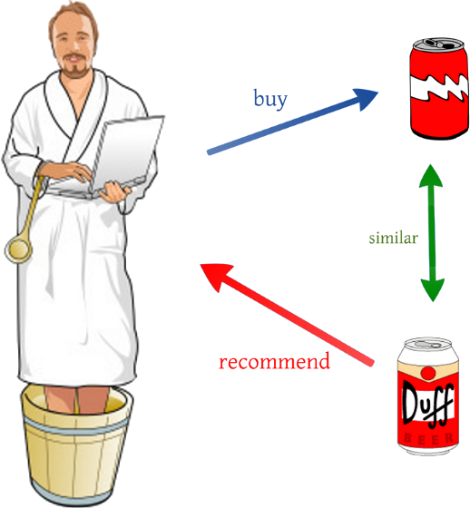

This are the simple example of CBF, as we can see if a person who likes beer with label A and if there exist another beer with label B who shares the same feature with the first beer. Therefore, the person who likes to buy beer A will most likely to buy beer B.

CBF proven to be a natural approach for RS in many problems. For instance, when a person watches a Starwars episode one and two. The most logical action is to recommend the third episode of the Starwars. However, the features of each items are hardly defined, the items context is dependable towards the descriptive of data. This problem will cause some user to get a similar recommendation which already showed to their profiles. In addition, Content-based filtering also ignores quality and popularity of items (R. Dong, L. Tokarchuk, and A. Ma, “Digging Friendship: Paper Recommendation in Social Network,” in Proceedings of Networking & Electronic Commerce Research Conference (NAEC 2009), 2009, pp. 21–28)

**Collaborative Filtering**

This approach is probably the second best approach for RS. The Collaborative Filtering (CF) is created by building a big dataset of user preferences for items then pair it to the other user with the same interest by calculating the similarities between them. The usual terms that CF tend to use is neighborhood.

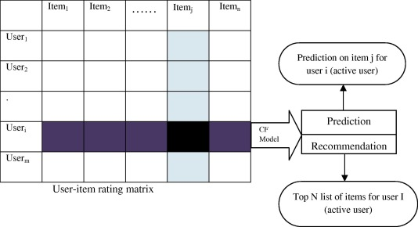

As we can see from the graph, CF use matrix to match targeted user from the other user perspective. By matching the matrix, the RS could create recommendation and prediction towards the user. () The major limitation for CF is the reliance towards user choices and the most common problem for using this algorithm is the cold start problem scenario. In this scenario, the items which presented to the user does not enough rating which will create a poor recommendation result to the user. By general CF can be categorize into two parts which are memory based and model based filtering.

**Memory based techniques**

The idea behind this technique is to find a relation between user and items from the database. The items that already rated by the user will search a neighbor that shared the same interest with the user. The neighbors usually have a history of doing or approving with the targeted user. For example, they both share the same interest for buying the particular item. The Memory based CF can be done by using two techniques which is user or item based technique.

The first technique (User Based) will calculate the similarity between user and compare their preference to the same item. After the data has been achieve, then the system will compute the prediction of rating.

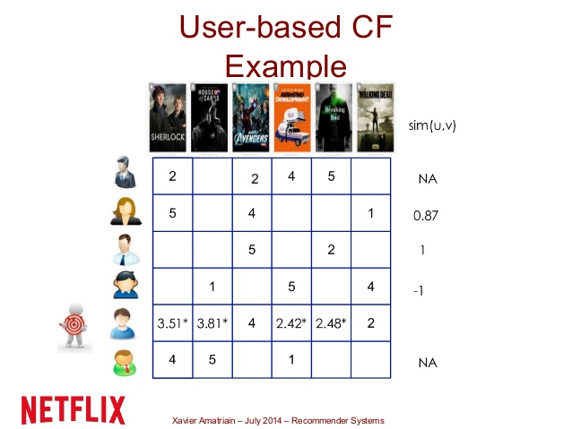

The illustration below shows; the user based CF was performing in the small data set of movie system. As we can see, the RS wants to predict the rate for each movie based on their neighbor who has the same interest to the same kind of movie.

The set of similar users can be identified by employing a threshold or selecting top-N. By using

**Su(uk) = {ua|rank su(uk, ua) ≤ N, xa,m 6= ∅}** where **|Su(uk)| = N. su(uk, ua)**

is the similarity between users k and a. We can calculate the number between each user below and produce the prediction. Noted that only the known test items ratings by similar users are used for this techniques.

The second technique for memory based recommendation is item based CF Recommendation. To find an item which the targeted user has liked before is the based foundation for this CF technique. The item based technique will retrieve all items that has been rated by targeted user. After the data has been collected then it will compare the number to the targeted items to determined the similarity between both items. Noted in this techniques takes only the known similar item ratings by the test user into account for prediction

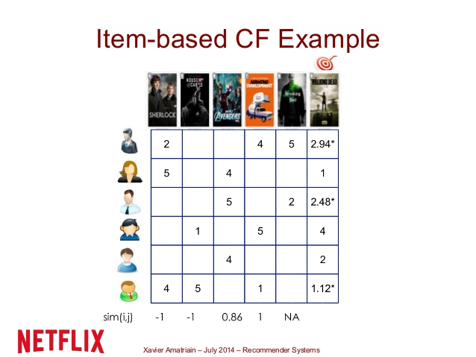

**Model based techniques**

This technique will utilize the whole database to generate prediction and recommendation. Model based use the previous rating in order to create or examine a model. This model will be revised as the system or ratings grow which will give a high quality for the user. One of the model based technique used in the real world is Neflix Prize. In brief, Netflix create a competition to public in order to improve their recommendation system. After several years pass by, in the last year of competition year (2007), Netflix Prize end with two top algorithms which is Singular Value Decomposition (SVD) and Restricted Boltzman Machine (RBM).

Both of the algorithm are only a part from many possible algorithms that can be apply for the model based technique recommendation. The use of each algorithm is depend on the style of the customer in selecting a product. In the section below, the author will describe some of common used algorithm when selecting model based technique for recommendation.

**Association Rule**

This data mining rules will predict the relations based on their presences for other items in a operation. Association rules are often used to analyze sales transactions. For example, it might be noted that customers who buy cereal at the grocery store often buy milk at the same time. In fact, association analysis might find that 85% of the checkout sessions that include cereal also include milk. This relationship could be formulated as the following rule. Association rules can form a very compact representation of preference data that may improve efficiency of storage as well as performance. Also, the effectiveness of association rule for uncovering patterns and driving personalized marketing decisions has been known for sometimes.

**Clustering**

Clustering techniques have been applied in different domains such as, pattern recognition, image processing, statistical data analysis and knowledge discovery [51]. Clustering algorithm tries to partition a set of data into a set of sub-clusters in order to discover meaningful groups that exist within them [52]. Once clusters have been formed, the opinions of other users in a cluster can be averaged and used to make recommendations for individual users. A good clustering method will produce high quality clusters in which the intra-cluster similarity is high, while the inter-cluster similarity is low. In some clustering approaches, a user can have partial participation in different clusters, and recommendations are then based on the average across the clusters of participation which is weighted by degree of participation [53]. K-means and Self-Organizing Map (SOM) are the most commonly used among the different clustering methods. K-means takes an input parameter, and then partitions a set of n items into K clusters [54]. The Self-Organizing Map (SOM) is a method for an unsupervised learning, based on artificial neurons clustering technique [55]. Clustering techniques can be used to reduce the candidate set in collaborative-based algorithms.

**Decision tree**

Decision tree is based on the methodology of tree graphs which is constructed by analyzing a set of training examples for which the class labels are known. They are then applied to classify previously unseen examples. If trained on very high quality data, they have the ability to make very accurate predictions [56]. Decision trees are more interpretable than other classifier such as Support Vector machine (SVM) and Neural Networks because they combine simple questions about data in an understandable manner. Decision trees are also flexible in handling items with mixture of real-valued and categorical features as well as items that have some specific missing features.

**Artificial Neural network**

ANN is a structure of many connected neurons (nodes) which are arranged in layers in systematic ways. The connections between neurons have weights associated with them depending on the amount of influence one neuron has on another. There are some advantages in using neural networks in some special problem situations. For example, due to the fact that it contains many neurons and also assigned weight to each connection, an artificial neural network is quite robust with respect to noisy and erroneous data sets [57].

ANN has the ability of estimating nonlinear functions and capturing complex relationships in data sets also, they can be efficient and even operate if part of the network fails. The major disadvantage is that it is hard to come up with the ideal network topology for a given problem and once the topology is decided this will act as a lower bound for the classification error.

**Link analysis**

Link Analysis is the process of building up networks of interconnected objects in order to explore pattern and trends [58]. It has presented great potentials in improving the accomplishment of web search. Link analysis consists of PageRank and HITS algorithms. Most link analysis algorithms handle a web page as a single node in the web graph [59].

Regression: Regression analysis is used when two or more variables are thought to be systematically connected by a linear relationship. It is a powerful and diversity process for analyzing associative relationships between dependent variable and one or more independent variables. Uses of regression contain curve fitting, prediction, and testing systematic hypotheses about relationships between variables. The curve can be useful to identify a trend within dataset, whether it is linear, parabolic, or of some other forms.

**Bayesian Classifiers**

They are probabilistic framework for solving classification problems which is based on the definition of conditional probability and Bayes theorem. Bayesian classifiers [36] consider each attribute and class label as random variables. Given a record of N features (A1, A2, …, AN), the goal of the classifier is to predict class Ck by finding the value of Ck that maximizes the posterior probability of the class given the data P(Ck|A1, A2, …, AN) by applying Bayes’ theorem, P(Ck|A1, A2, …, AN) ∝ P(A1, A2, …, AN|Ck)P(Ck).

The most commonly used Bayesian classifier is known as the Naive Bayes Classifier. In order to estimate the conditional probability, P(A1, A2, …, AN|Ck), a Naive Bayes Classifier assumes the probabilistic independence of the attributes that is, the presence or absence of a particular attribute is unrelated to the presence or absence of any other. This assumption leads to P(A1, A2, …, AN|Ck) = P(A1|Ck)P(A2|Ck)… P(AN|Ck). The main benefits of Naive Bayes classifiers are that they are robust to isolated noise points and irrelevant attributes, and they handle missing values by ignoring the instance during probability estimate calculations.

However, the independence assumption may not hold for some attributes as they might be correlated. In this case, the usual approach is to use Bayesian Networks. Bayesian classifiers may prove practical for environments in which knowledge of user preferences changes slowly with respect to the time needed to build the model but are not suitable for environments in which users preference models must be updated rapidly or frequently. It is also successful in model-based recommendation systems because it is often used to derive a model for content-based recommendation systems.

**Matrix completion techniques**

The essence of matrix completion technique is to predict the unknown values within the user-item matrices. Correlation based K-nearest neighbor is one of the major techniques employed in collaborative filtering recommendation systems [60]. They depend largely on the historical rating data of users on items. Most of the time, the rating matrix is always very big and sparse due to the fact that users do not rate most of the items represented within the matrix [61]. This problem always leads to the inability of the system to give reliable and accurate recommendations to users. Different variations of low rank models have been used in practice for matrix completion especially toward application in collaborative filtering [62].

Formally, the task of matrix completion technique is to estimate the entries of a matrix, M∈Rm×n, when a subset, Ω C{(i,j):1⩽i⩽m,1⩽j⩽n} of the new entries is observed, a particular set of low rank matrices, View the MathML source, where U∈Rm×k and V∈Rm×k and k≪min(m,n). The most widely used algorithm in practice for recovering M from partially observed matrix using low rank assumption is Alternating Least Square (ALS) minimization which involves optimizing over U and V in an alternating manner to minimize the square error over observed entries while keeping other factors fixed.

Candes and Recht [63] proposed the use of matrix completion technique in the Netflix problem as a practical example for the utilization of the technique. Keshavan et al. [64] used SVD technique in an OptSpace algorithm to deal with matrix completion problem. The result of their experiment showed that SVD is able provide a reliable initial estimate for spanning subspace which can be further refined by gradient descent on a Grassmannian manifold. Model based techniques solve sparsity problem. The major drawback of the techniques is that the model building process is computationally expensive and the capacity of memory usage is highly intensive. Also, they do not alleviate the cold-start problem.

**Hybrid Technique**

Hybrid filtering technique combines different recommendation techniques in order to gain better system optimization to avoid some limitations and problems of pure recommendation systems [74] and [75]. The idea behind hybrid techniques is that a combination of algorithms will provide more accurate and effective recommendations than a single algorithm as the disadvantages of one algorithm can be overcome by another algorithm [65]. Using multiple recommendation techniques can suppress the weaknesses of an individual technique in a combined model. The combination of approaches can be done in any of the following ways: separate implementation of algorithms and combining the result, utilizing some content-based filtering in collaborative approach, utilizing some collaborative filtering in content-based approach, creating a unified recommendation system that brings together both approaches.

**Weighted hybridization**

Weighted hybridization combines the results of different recommenders to generate a recommendation list or prediction by integrating the scores from each of the techniques in use by a linear formula. An example of a weighted hybridized recommendation system is P-tango [76]. The system consists of a content-based and collaborative recommender. They are given equal weights at first, but weights are adjusted as predictions are confirmed or otherwise. The benefit of a weighted hybrid is that all the recommender system’s strengths are utilized during the recommendation process in a straightforward way.

**Switching hybridization**

The system swaps to one of the recommendation techniques according to a heuristic reflecting the recommender ability to produce a good rating. The switching hybrid has the ability to avoid problems specific to one method e.g. the new user problem of content-based recommender, by switching to a collaborative recommendation system. The benefit of this strategy is that the system is sensitive to the strengths and weaknesses of its constituent recommenders. The main disadvantage of switching hybrids is that it usually introduces more complexity to recommendation process because the switching criterion, which normally increases the number of parameters to the recommendation system has to be determined [34]. Example of a switching hybrid recommender is the DailyLearner [77] that uses both content-based and collaborative hybrid where a content-based recommendation is employed first before collaborative recommendation in a situation where the content-based system cannot make recommendations with enough evidence.

**Cascade hybridization**

The cascade hybridization technique applies an iterative refinement process in constructing an order of preference among different items. The recommendations of one technique are refined by another recommendation technique. The first recommendation technique outputs a coarse list of recommendations which is in turn refined by the next recommendation technique. The hybridization technique is very efficient and tolerant to noise due to the coarse-to-finer nature of the iteration. EntreeC [34] is an example of cascade hybridization method that used a cascade knowledge-based and collaborative recommender.

**Mixed hybridization**

Mixed hybrids combine recommendation results of different recommendation techniques at the same time instead of having just one recommendation per item. Each item has multiple recommendations associated with it from different recommendation techniques. In mixed hybridization, the individual performances do not always affect the general performance of a local region. Example of recommender system in this category that uses the mixed hybridization is the PTV system [78] which recommends a TV viewing schedule for a user by combining recommendations from content-based and collaborative systems to form a schedule. Profinder [79] and PickAFlick [80] are also examples of mixed hybrid systems.

**Feature-combination**

The features produced by a specific recommendation technique are fed into another recommendation technique. For example, the rating of similar users which is a feature of collaborative filtering is used in a case-based reasoning recommendation technique as one of the features to determine the similarity between items. Pipper is an example of feature combination technique that used the collaborative filter’s ratings in a content-based system as a feature for recommending movies [81]. The benefit of this technique is that, it does not always exclusively rely on the collaborative data.

**Feature-augmentation**

The technique makes use of the ratings and other information produced by the previous recommender and it also requires additional functionality from the recommender systems. For example, the Libra system [42] makes content-based recommendation of books on data found in Amazon.com by employing a naïve Bayes text classifier. Feature-augmentation hybrids are superior to feature-combination methods in that they add a small number of features to the primary recommender.

**Meta-level**

The internal model generated by one recommendation technique is used as input for another. The model generated is always richer in information when compared to a single rating. Meta-level [17] hybrids are able to solve the sparsity problem of collaborative filtering techniques by using the entire model learned by the first technique as input for the second technique. Example of meta-level technique is LaboUr [82] which uses instant-based learning to create content-based user profile that is then compared in a collaborative manner.

**DBMS**

A database management system (DBSM) is a tools for computer system in order to create and maintain databases. This system provides a organized way for user and programmers in order to do a Create, Update, Read, and Delete data (CRUD). This tools have a core function for maintaining three important parts which are the data, data schema which define the database structure, and database engine which provide an access, security, and managing the data. This three core function help to provide concurrency, safety, data integrity, and uniform management procedure. In addition DBSM also capable for doing roleback (running a previous version of a database), restarts, and recovery function.

The DBMS is probably a very useful tools in order to providing a unified view of data that can be accessed by several user using different platforms and locations. A DBSM can constraint the limit regarding the data access for each user. In addition, the end user and programs are capable for understanding where the data is stored because the DBMS handle all the requests.

There are several popular DBMS model such as Relational database management system (RDMS) which adaptable to most problem in software engineering. This database support the relational data model, which defined by the table name and a certain number of data with data types. The RDMS use record as a row in the table which contain several values for each attributes. The basic operation for this RDMS include classical set of operations such as union, intersection, and difference. In addition, the user also capable for doing a selection for a subset of record with several criteria such as contain. The RDMS also capable for doing projection which able to select a subset of attributes in the table. Finally the most useful operation in RDMS is join, which enable the user to combine multiple table. The example for RDMS is Oracle. However, although it could solve almost the problem, the RDMS can be quite expensive for development.

The next type of DBSM is NoSql DBSM which suited for loosely data structure that might grow in the future. NoSql also can be defined as Document Stores. This database model has several characteristic, firstly, the records does not have uniform structure (different records might have different columns). Secondly, the types of values in each column can be differ from one another. In addition, each column may have more than one value. Finally, record can have a nested structure (append values). In the real practice, the Document stores often use internal notations such as JSON. Wide column stores is another example of DBSM which could handle a very large numbers of dynamics columns. This type of DBSM can be seen as two dimensional key stores values. Since the column and record key are not fixed. This type of DBSM share the same attributes with the NoSQL DBMS but the implementation in the real practice is quite different.

According to data from DB-Engines a website that tracks database popularity, Graph databases were the fastest growing type of database in 2014. This database represent data in a graph projection using terms nodes and edges. By doing this, graph database allow easy processing and simple calculation of the data. An example for graph database is neo4j graph database.

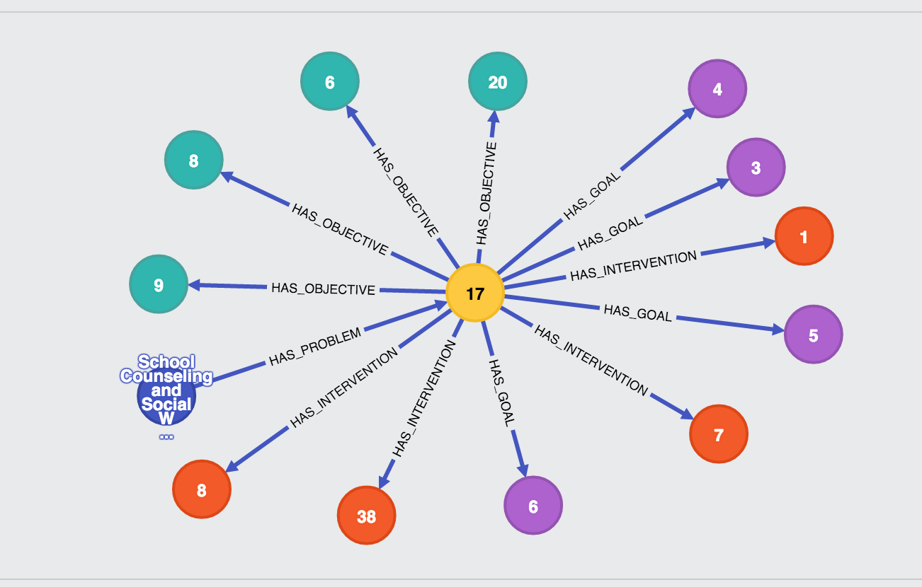

In the figure below shows the representation neo4j for data (node) with their edge. As we can see each of node has different color representing its model and the arrow represent the edge as the function for each node. The pro’s for using graph database according to Josep Lluis Larriba Pey are the graph database allow programmer to deep transversal quicker than traditional database. Moreover, the graph database tend to query faster when finding a connection between nodes which shares the same preferences in their edge. The cons for graph database is the maturity for its system because it is a growing technology.

**Big Data Processing**

The main function or purpose for using big data processing is to help a user to create more informative business decision by doing research and development in a big amounts of data transaction. This process could use a logs of a web server, social media content, social network action reports, emails, call details, and many more. This big data can be analyzed thanks to the software tools that capable doing predictive analytics, data mining, statistical and text analytics. There are several cases that need to be calculated when doing a big data processing. Firstly, some of data warehouses might not be able to process a big set of data that need to be shown instantly (real time data). This example can be seen in a applications of oil and stock exchanges. To handle this problem, a newer technology must be applied to the company system such as using Hadoop and related tools such as YARN, Elastic Search, Spark, etc.

**MODEL FROM PAPER**

In the past 10 years, more than 200 studies regarding promotion has been published compare with year 1965 – 1983 which only 40 studies shown. Many definitions of promotions has been pass around the internet but it shares the common idea that promotions are a momentary and tangible modification of supply which has a purpose to create an impact towards customer, retailers, and sales behavior (Vemette 1990; Desmet 1991; Guilbert 1991; Ward and Hill 1991; Jones 1992).

In addition, according to .. the most widely accepted promotion topology contains three core foundations which are retail promotions, trade promotions, and consumer promotions. The topology is based on the nature of profits, effort, and relationship to the other product.

